STAT 350 Introduction to R

Sources of R documents:

100 page Introduction to R from the R website http://www.ics.uci.edu/~jutts/st108/R-intro.pdf

Practical Regression and Anova using R, by Julian Faraway
http://cran.r-project.org/doc/contrib/Faraway-PRA.pdf

1. Installing R

Go to the Michigan Tech mirror of the R home page: http://cran.mtu.edu/
(You can find more CRAN mirrors on http://www.r-project.org/; use the one which is close to your location)
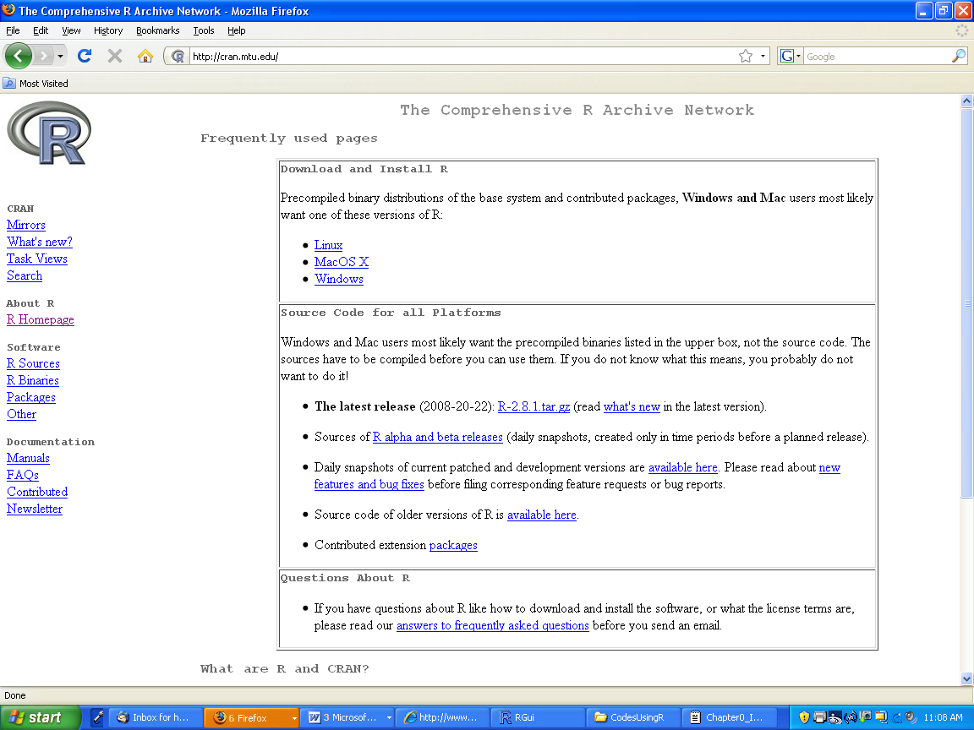

Under “Download and Install R,” choose “Linux,” “MacOS X” or “Windows.” If you choose Windows, on the next page choose “base,” and on the following page choose “Download R 2.14.1 for Windows” to download the setup program.
If you choose MacOS X or Linux you will need to read through the instructions to find the downloads you need for your machine.
Once you have downloaded the setup program, execute it and follow the instructions for installing R on your system. If you have an earlier version of R already installed, you may continue to use it, or you can uninstall it and then install the most recent version, which is R-2.14.1.

Run R

Once R is installed, open it. You will see the following interface:

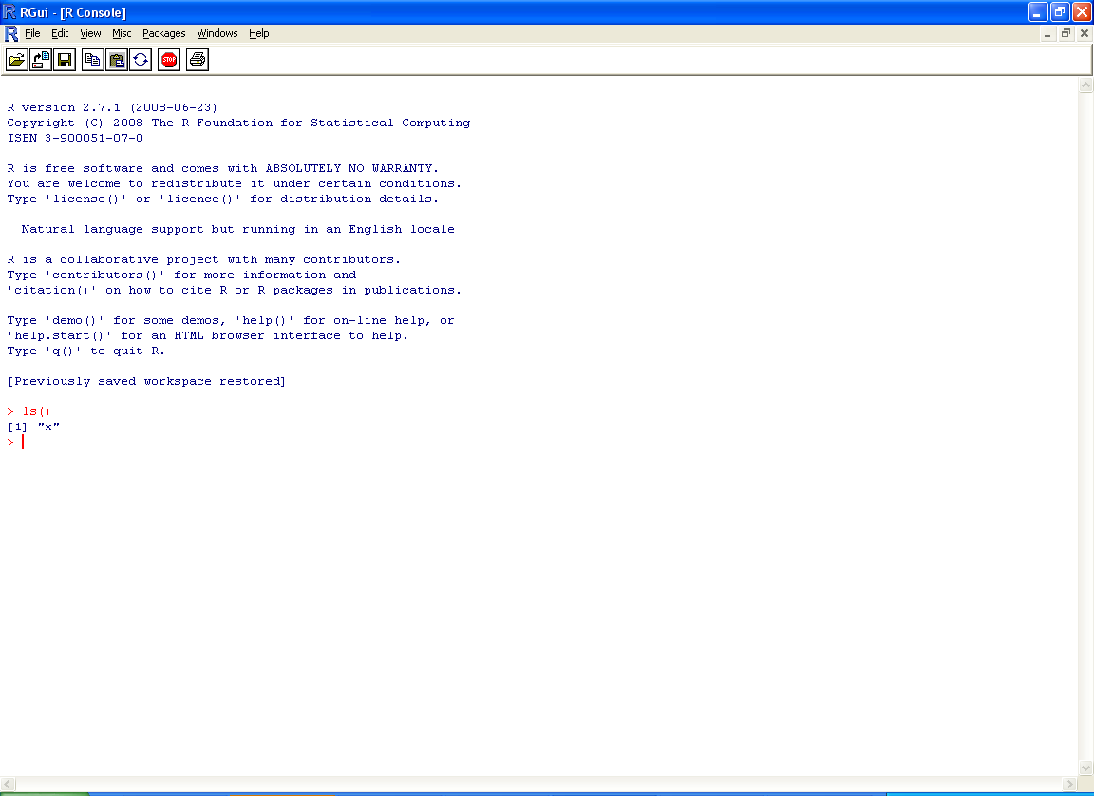

The > symbol is a prompt, after which you will enter a command using R syntax. We will provide you with all the commands you will need for this course. Note that to end an R session you can type q() at the prompt, or you can go to the File menu and select Exit. You will be asked, “Save workspace image?” Answer “Yes” if you have created any new objects (to be discussed soon) that you may want to use again in a future session.

How to use help in R?
> ?plot # help page for plot
> help(plot) # help page for plot

If you do not know the function's name, try the following and search using the keyword
> help.start()
2 Installing RStudio

https://www.rstudio.com/products/rstudio/download3/

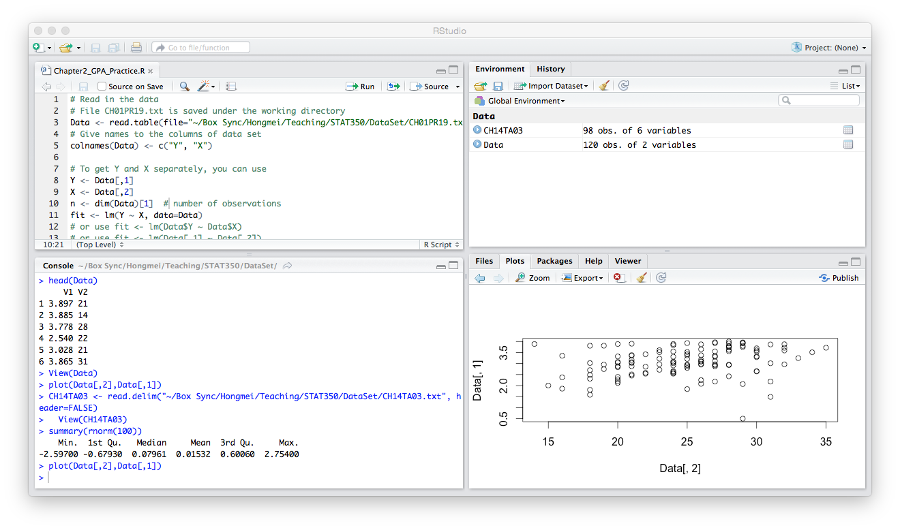
3. Getting data set into R

Usually you will want to import data from a file corresponding to data associated with a homework problem. Such a file will usually end with the extensions .txt or .dat. The data files for this course will always be available on the CD that comes with the text and/or on the course web page. A data file will consist of columns of numbers, with nothing separating the columns but “white space.” If each column has a title on top describing what the data in the column represents (e.g., “age,” “weight,” “income,” etc.), we will say that the file has a “header.”

Working directory The easiest way to import the data into R and have it readily available for the current and future sessions is to first save the data file into the R-2.8.1 working directory. When you installed R, this directory was placed on your hard drive. In Windows, it will usually be C:\Program Files\R\R-2.14.1. To put files there from the book CD, locate the file on the CD then copy it into the R-2.14.1 directory. Of course you can decide which directory is your working directory. For example mine is C:\stat350.Within R, you can find out what the current working directory is by choosing Change dir… from the File menu. Alternatively, you can load the file from the CD or the course web page.

Suppose you want to work with the data from Problem 19 of Chapter 1, which is in a file named CH01PR19.txt which you have saved from the CD or the course web page into your R working directory. Assume the file has no header. You will want to create a Table object in R containing this data. First choose an appropriate name for the table. Assume you choose to name it Data. Then at the R command prompt type
> Data <- read.table("CH01PR19.txt")
and hit the “Enter” key (but don’t type the leading > symbol; it’s already there!). Then there will be a Table object in R named Data containing the data in rows and columns. To view it, you would type
> Data
at the command prompt and hit Enter. However, if it is a large file, you might not be able to view the whole table at once. In that case, try
> head(Data)
Note that, in the absence of a header, the columns will be named V1, V2, etc., and the rows will be numbered.

Now if the file does have a header (which you may have added yourself), you need to change the above command to
> Data <- read.table("CH01PR19.txt", header=TRUE)
In this case, when you view the file you will see the title for each column at the top of each column instead of V1, V2, etc. R regards these titles as names for the columns, and not as data.

If you want to load the data file from some other directory, you need to type the full path name in the read.table() command. For instance,
> Data <- read.table(file="C:/stat350/CH01PR19.txt", header=FALSE)

Now suppose the file Data has two columns, and the first column is the GPA, while the second column is ACT score. If you would like to rename the columns in your R data table so that each column has a descriptive title, you could give the R command:
> names(Data) <- c("GPA", "ACT")
Then when you view the file the titles of the columns will have the new names you assigned. Note that you can also give the columns these titles in the data file before you load it into R, and then use the header=TRUE setting when loading. Also, to avoid errors, you should never include a space in the title of any column

Save data to file Intro.csv in your folder. This is a .csv type file, .txt type is fine too.
> write.table(Data, "C:/stat350/Intro.csv", col.names=TRUE, sep=",")

If you want to see which R objects are currently in your R environment, you can type
> ls()
If you no longer need one or more of these objects, you can remove them. For instance, if you are done with Data, you can type
> rm(Data)
Then Data will no longer be in your current R environment. When you quit R, if you wish to keep all the new objects in your current R environment, be sure to answer “Yes” when asked, “Save workspace image?”

Input data by hand. Here both Return and New are vectors.
> Return <- c(74,66,81,52,73,62,52,45,62,46,60,46,38)
> New <-c(5,6,8,11,12,15,16,17,18,18,19,20,20)

4. Plotting scatter plot and simple linear regression
Suppose the data for Problem 19 of Chapter One has been stored in an R object named Data which has two columns, the first column named GPA and the second column named ACT. You want to make a scatterplot in R with ACT scores on the horizontal axis and GPA on the vertical axis. The R command is:
> plot(Data$ACT, Data$GPA)
Note that the dollar sign is used to reference either column in the table named Data. The first argument to the plot() function is the column corresponding to the variable associated with the horizontal axis, and the second argument is the column corresponding to the variable associated with the vertical axis. Alternately, you could define two new vector variables, X and Y, to hold the data of the individual columns, and use these vectors as the arguments to the plot() function:
> X <- Data$ACT
> Y <- Data$GPA
> plot(X, Y)
For now we will stick with the former approach. The resulting plot appears in the R Graphics Device within the R interface. Click on it to view it, save it, print it, etc.

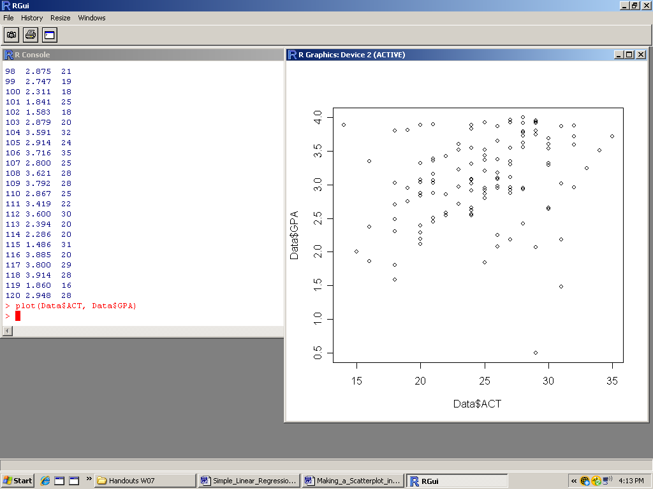

Note that whenever you make a new plot the old one will disappear (this can be changed; but not easily), so save it if you don’t want to lose it. However, the current scatterplot is inadequate. It has no title, the axis labels aren’t very informative, and the points are open circles rather than dark filled-in circles. To fix this, we can add some additional settings to the plot() command:
> plot(Data$ACT, Data$GPA, main="Problem 1.19",
xlab="ACT Test Score", ylab="Freshman GPA", pch=19)
Now we obtain a much nicer scatterplot:

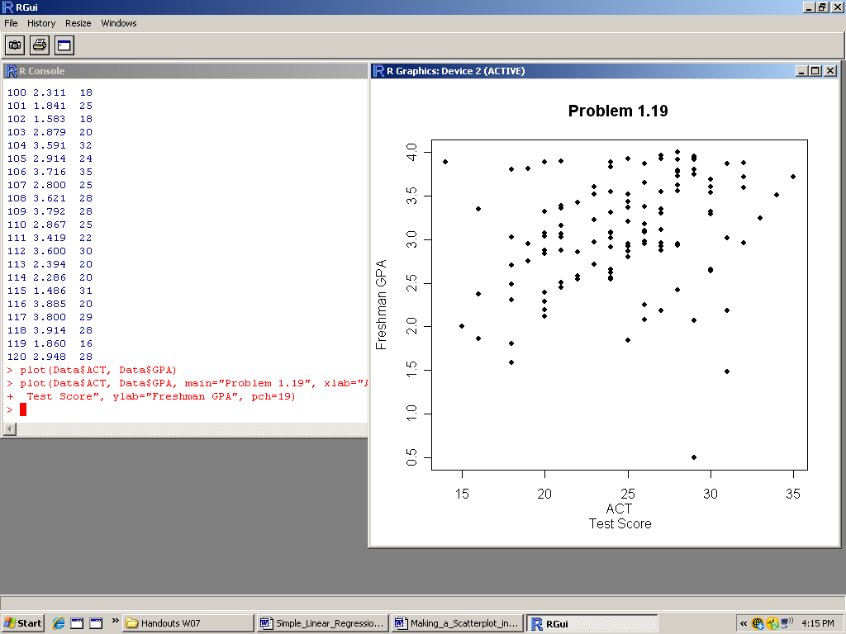

Whatever you put in quotes after main= will be the title for the plot. Whatever you put in quotes after xlab= and ylab= will the the labels for the horizontal and vertical axes, respectively. The number after pch= is a code for the symbol to use for the points. You can try other numbers from 1 to 25. You can also use any symbol on your keyboard for the points, including numerals and letters, using quotes. For instance, if you want to use an asterisk for the points, type pch="*".

You may want to also add a plot of the estimated regression function to the scatterplot of the data. This assumes you have already obtained the least squares estimates of the regression coefficients (see “Simple Linear Regression in R”).
> fit <- lm(Data$GPA ~ Data$ACT)
> fit <- lm(GPA~ACT, data=Data) # another option
> abline(fit)

The line will appear superimposed over the data. You can also just type the actual values for the estimated intercept and slope if you prefer.

To save your plot, click anywhere on the plot, then on the menu bar choose “File,” then “Save as.” Choose the format in which you want to save the plot, then where you want to save it on your drive.

Check the estimates for the intercept and slop:
> fit

Compute fitted values:
> fit$fitted.values

Compute residuals:
> fit$residuals

Compute the estimate of σ², that is, the MSE:
> n <- dim(Data)[1]
> sum(fit$residuals^2)/(n-2)

5. Useful help websites
1) Quick-R: www.statmethods.net
2) www.rseek.org
3) www.r-bloggers.com

